|  |
| --- |
| **Black Bear Bank Project Report** |

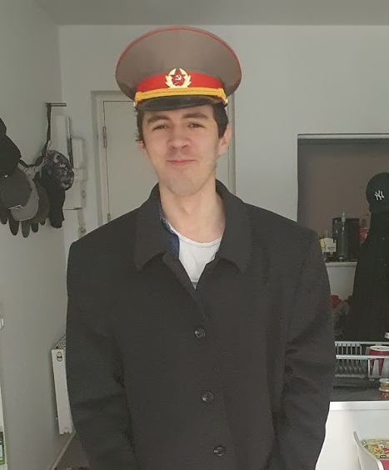

Mircea Ionut Dobre - 293117 Pavel Balan - 293129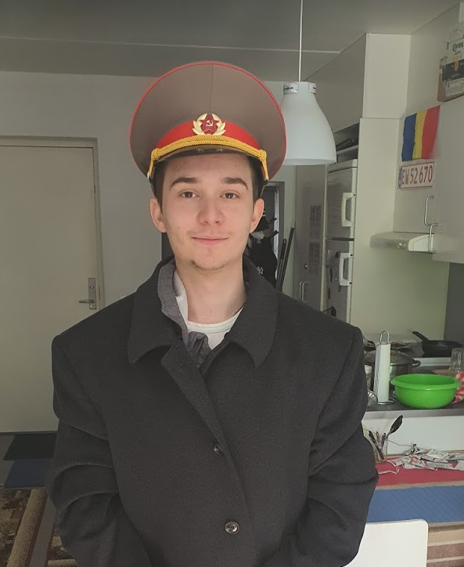

Sandut Chilat - 293086 Manuel Gabriel Hagiu - 293144

**Supervisors:**

[Henrik Kronborg Pedersen](https://via.itslearning.com/Dashboard/#)  
 [Joseph Chukwudi Okika](https://via.itslearning.com/Dashboard/#)

**VIA University College**

**????? characters**

**Software Technology Engineering**

**2nd semester**

**May 2020**

**Table of content**

Abstract **4**

Introduction **5**

Analysis **7**

Design **13**

Implementation **32**

Test **42**

Results and Discussion **46**

Conclusions **47**

Project future **49**

Sources of information **51**

Appendices **53**

# Abstract

*The* ***Black Bear Bank*** *represents an online banking system that improves upon the currently existing traditional ones. It allows for the registration of clients through requests to the staff, the latter of which are registered into the system by the manager.*

*A client can have multiple accounts in different currencies. He can transfer money from one of them to another, whether it is in-between his own accounts, or to another client’s account. It is possible to withdraw or add money to any account - that functionality fills the lack of a physical ATM. A client is also able to request loans in DKK that have to be approved by a staff.*

*Based on a customer’s potential needs, 10 use cases and 18 system requirements have been established. All of them have been successfully implemented into the software.*

*The software has been written in Java. The GUI has been made using the JavaFX platform and the JFoenix JavaFX material design library. The relational database management system used is PostgreSQL, while the database itself is being stored locally.*

*After testing using the Black Box method, no unforeseen issues or exceptions have been found. The detailed results are contained in the “Test” section.*

# Introduction

Traditional banking systems are the most popular type of financial institutions that aid in monetary management. The customers of a traditional bank are limited in their actions in terms of the bank’s regulations and current country legislation. Potential customers can do a few basic things such as: opening a bank account, withdrawing and depositing money - possibly through an ATM, exchanging between currencies (without a fee if one is the client of the specific bank), taking loans and stock exchange. All the walking that is done by a customer - from home to bank, or from the central bank branch to a secondary branch is time-consuming and today in the 21st century - time, speed, service availability and the lack of necessity of having to visit the offices are important, as every minute has a cost and in the end, time is money.

An alternative to the traditional bank is the neobank ([Aleksandre B, 2019](https://bitnewstoday.com/news/neobanks-have-arrived-is-the-market-trembling/)) - a type of direct bank that operates exclusively online without traditional physical branch networks. Some of them have also brought in new possibilities - such as cryptocurrency trading. Currently, in the modern world, people are used to traditional banking systems with physical branches where one has to wait for hours on end and stay in endless lines, just to do something that is achievable in a few clicks through web-banking.

Online banking has had a gradual increase in popularity in the past decade, and this trend is observed mostly in highly developed countries. For example, as of 2018, Nordic countries including Norway, Denmark, Finland, and Sweden, all had online banking penetration rates of over 80 percent. In stark contrast, North Macedonia, Romania, and Bulgaria had penetration rates lower than 10 percent. The following statistics show a gradual increase in the popularity of online banking across Great Britain between 2007 and 2019 ([Cherowbrier, 2019](https://www.statista.com/aboutus/our-research-commitment)):

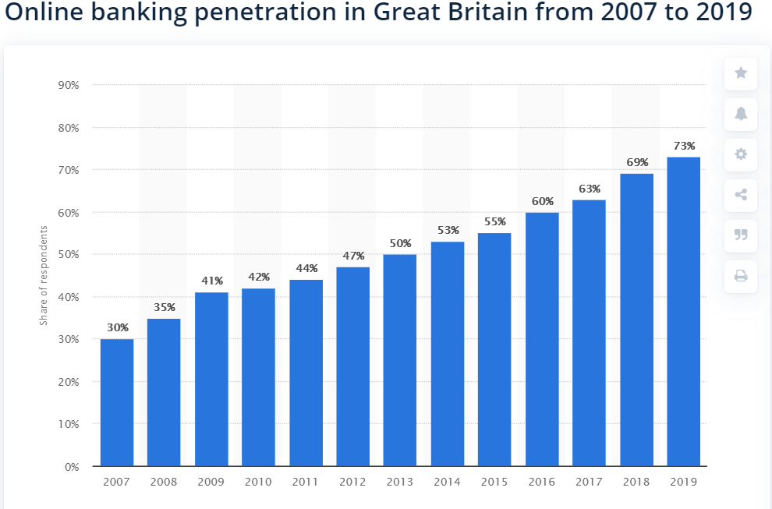



*Figure 1 - Online banking penetration in Great Britain from 2007 to 2019*

Another available solution available to customers is the Chime neobank. It allows the users to exchange funds between several currencies and make inter-bank transfers, all without a fee. However, it is only available to customers from the United States and it does not offer loans, something required for a full and comprehensive neobank system.

In conclusion, following the aforementioned statistics, more and more people are transitioning to an online solution for banking, as the traditional means of the financial activities through physical bank branches prove to be time-consuming and inefficient.

# Analysis

* 1. **User Stories**

|  |  |  |
| --- | --- | --- |
| **As a(n)...** | **I want too...** | **so that...** |
| Client | Take loans | I can have more money to spend. |
| Client | View exchange rates | I can decide on managing funds. |
| Client | Add/Withdraw funds from accounts | I can control my balance upon need. |
| Client | Transfer funds to other accounts while automatically convert to new currency when needed | Transfer to people or pay for services/products. |
| Client | View current account situation | I can make future financial decisions. |
| Client | View transaction history | I can make sure no mistakes were made. |
| Client | Close/open new accounts in any currency | I can create savings accounts and have multiple currencies on hand |
| Client | Close bank account | I am no longer part of this banking system |
| Client | Change password/telephone/email | Manage my personal data |
|  |  |  |
| Staff | Accept new client registration requests | A new client can use our banking system |
| Staff | View client data | Contact a customer in case an action is needed |
| Staff | Change client password | A client can continue using his account in case he forgets his previous one. |
| Staff | Accept client loans | A customer has more money to spend |
| Staff | View exchange rates | They can make financial advice to the clients |
|  |  |  |
| Manager | Can do all of the functions that staff can do | All of the above from staff |
| Manager | Close the server | The software is stopped in case it is needed |
| Manager | Create/delete staff accounts | Manage the employee accounts |
| Manager | Edit/view exchange rates | Set exchange rates according to the current prices |

* 1. **Use case diagram**

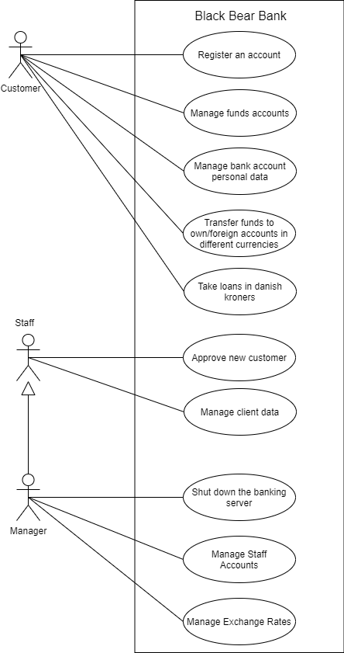

*Figure 2 - Use Case diagram*

* 1. **Use case descriptions and corresponding activity diagrams**

|  |  |
| --- | --- |
| **Use case** | **Manage funds accounts** |
| **Summary** | A valid amount of funds can be deposited into the customer’s account or withdrawn from it , the customer can close (delete) one of his accounts or he can open a new one in a preferred currency. |
| **Actors** | Customer |
| **Precondition** | 1. For depositing: An account with the corresponding account number must exist. 2. For withdrawing: The account must exist. |
| **Postcondition** | 1. For depositing: The selected amount will be deposited on the account with the corresponding account number. 2. For withdrawing: The selected amount will be withdrawn from the selected account. |
| **Base sequence** | I) For depositing:   1. Select the account number of the desired account from the drop-down list. 2. Enter the desired amount you wish to deposit. 3. Click “Deposit”.  * If the entered amount is illegal, go to step 2.   II) For withdrawing:   1. Select the account number from the drop-down list. 2. Enter the desired amount you wish to withdraw. 3. Click “Withdraw”   III) For closing an account:   1. Select the account number from the drop-down list. 2. Press the “Delete” button. 3. In the pop-up window press “ok” if you are sure to delete this specific account or press “cancel” and go to III step 1.   IV) For opening an account:   1. In the “Accounts” section , select a currency in which you want to open the account. 2. Add a description or leave it blank. 3. Press the “Create” button. 4. In the pop-up window press “ok” if you are sure to open this specific account or press “cancel” and go to IV step 1. |
| **Exception sequence** | I)2a. If the entered amount is illegal or greater than the one currently existing in the account, go to I step 2.  II)2a. If the entered amount is illegal or greater than the one currently existing in the account, go to II step 2.  III)2a. If the selected account is not empty go back to III step 1. |
| **Note** | The entered amount must only be made up of positive numbers, not greater than 2 147 483 647.  Main account DKK cannot be deleted.  If the account is not empty and it's not possible to be deleted , just transfer the money to another account. |

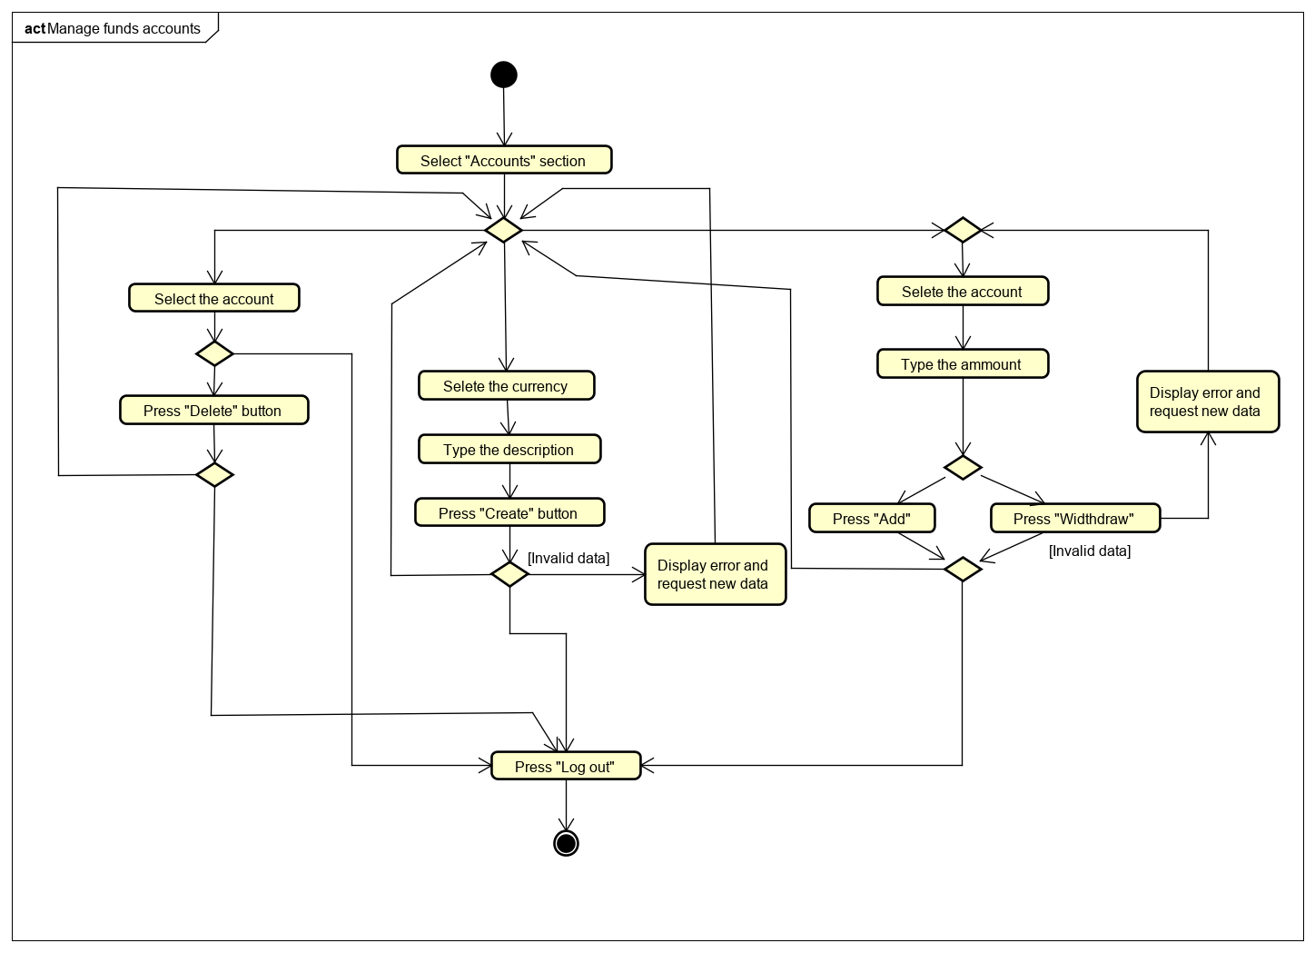

The rest of the use cases and their corresponding activity diagrams are in appendix X and respectively Y.

# Design

**Domain model**

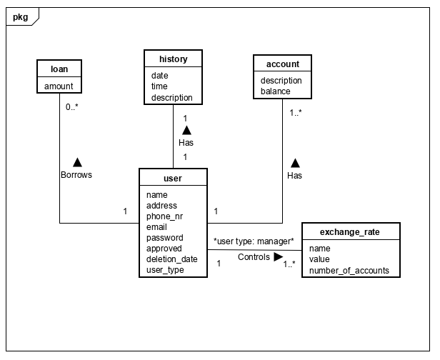

*Figure 3 - Domain Model*

* 1. **System architecture**

The software is divided into the client-side and the server-side. The connection between the two is made using sockets, following the mediator design pattern. Additionally, the client-side implements the MVVM design pattern for a structured code-base and GUI. Alongside MVVM, for more fluid communication between the mediator and the ViewModel package, the Observer pattern has been used. The following patterns, including the packages containing their respective classes, are explained in detail below.

**4.1.1 Client side**

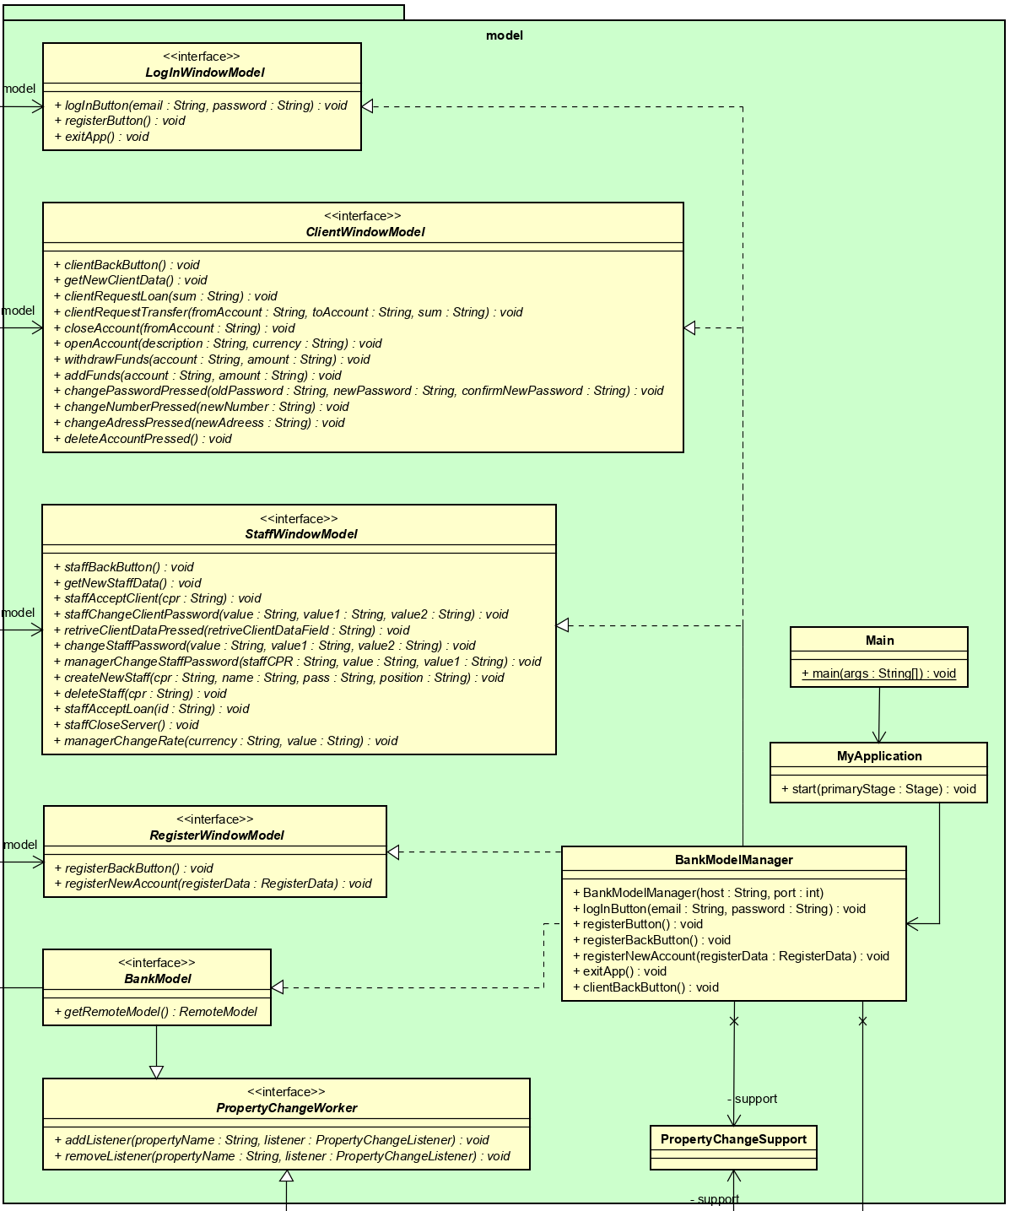

*Figure 4 - Client side model package*

Main is responsible for launching MyApplication, which in turn is responsible for instantiating the BankModelManager, the ViewModelFactory and the ViewHandler.

BankModelManager implements BankModel, ClientWindowModel, LogInWindowModel, RegisterWindowModel, StaffWindowModel.

PropertyChangeSupport class is part of the observer pattern.

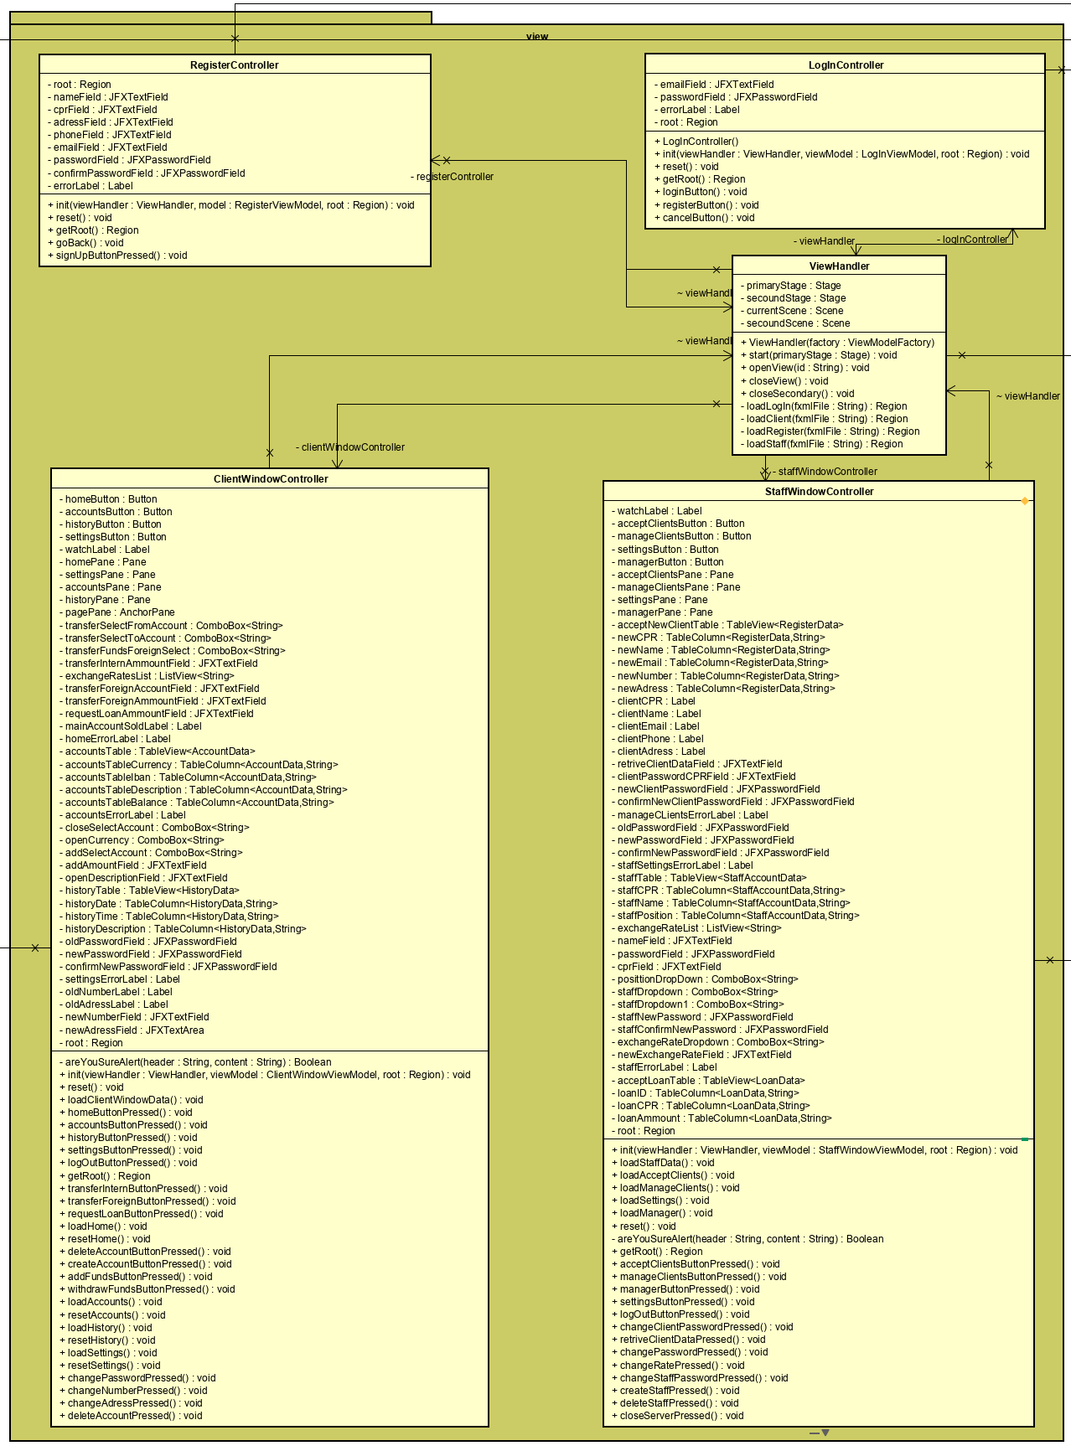

*Figure 5 - Client side view package*

ViewHandler handles all the scenes and the stages.

RegisterController, LogInController, ClientWindowController, StaffWindowController initialize their respective view. They all contain JavaFX elements as attributes, which constitute the visual layout of the software.

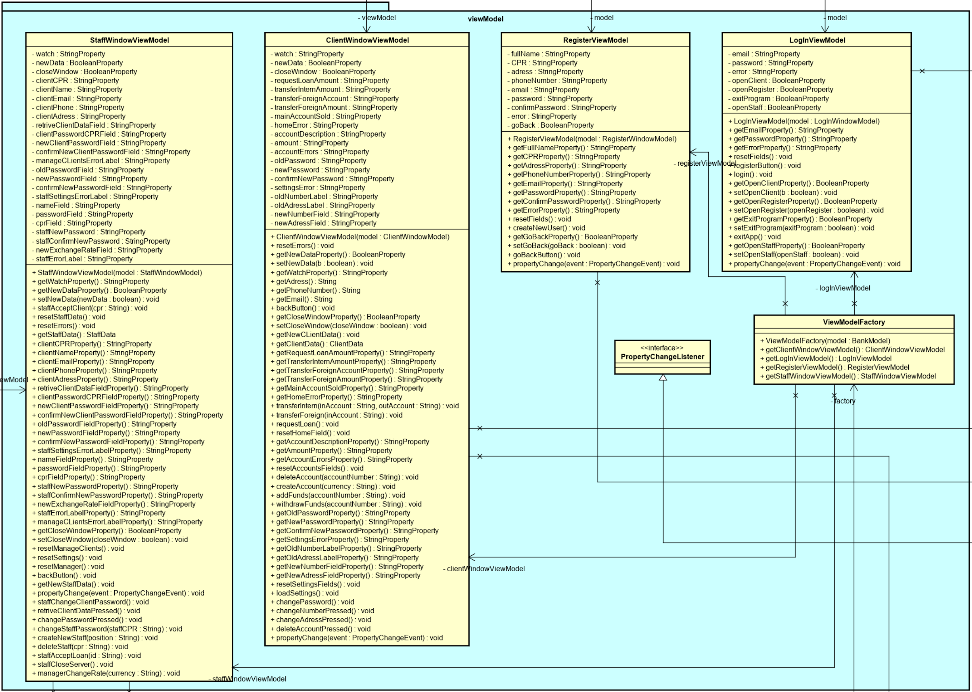

*Figure 6 - Client side viewModel package*

The ViewModelFactory initializes all the ViewModel classes - ClientWindowViewModel, LogInViewModel, RegisterViewModel, StaffWindowViewModel, that in turn, communicate the data from the model to the view in the correct format. The ViewModelFactory represents the Factory Method creation design pattern.

The 3 packages above (model, view, viewModel) follow the MVVM design pattern. This design pattern has been used in order to separate the view layer from the model and to remove the code related to software logic from the GUI. All the model data is stored in the data package presented below:

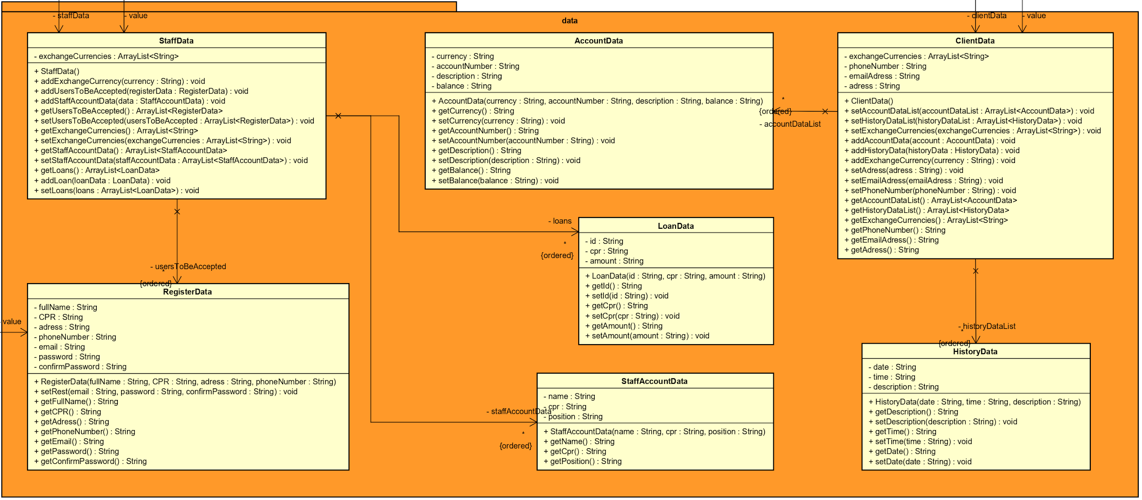

*Figure 7- Client side data package*

StaffData, AccountData, ClientData, HistoryData, LoanData, StaffAccountData, RegisterData represent the classes of all the respective objects and contain their attributes, constructors, getters, setters, and some basic functionality.

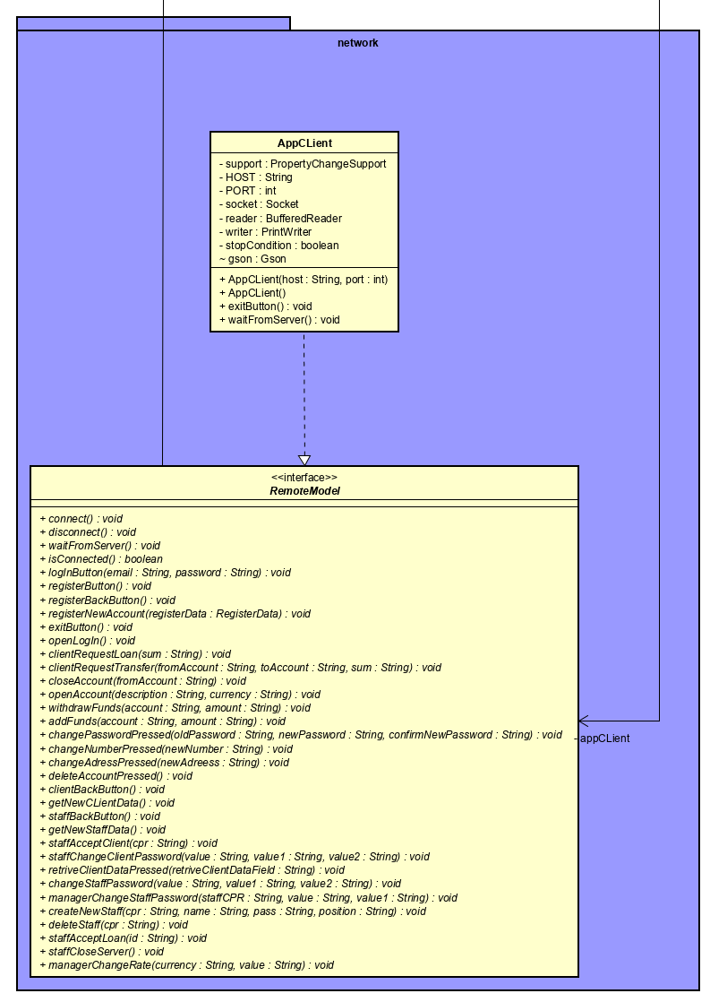

*Figure 8 - Client side network package*

AppClient implements RemoteModel and connects the client-side software to the server-side through sockets. The data is communicated through Gson (Google version of Json) using TCP (Transmission Control Protocol) sockets.

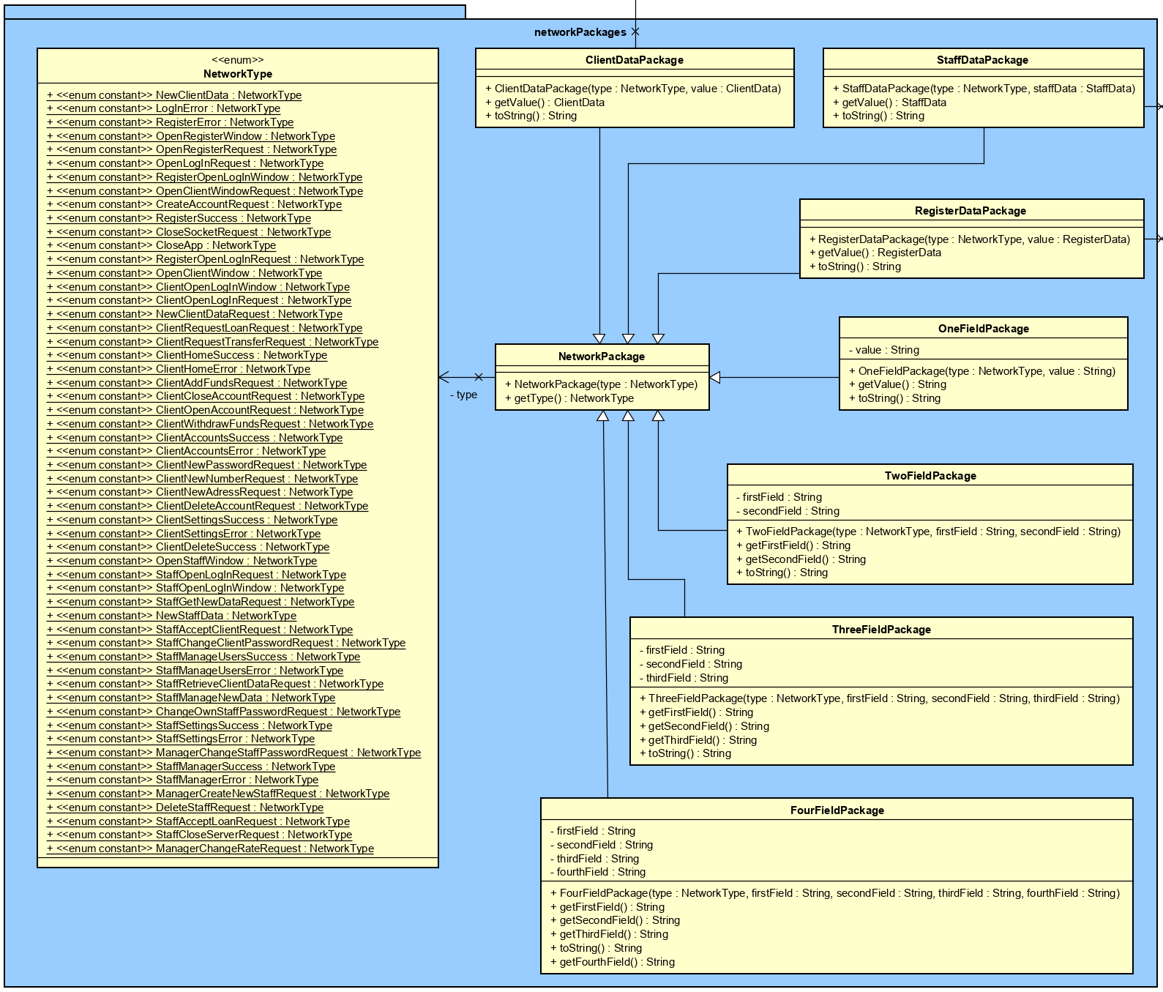

*Figure 9 - Client side networkPackages package*

All the NetworkPackage classes are used as wrappers for data to be sent to the server. The NetworkType holds all the types of network requests. The field packages (OneFieldPackage, TwoFieldPackage, TreeFieldPackage, FourFieldPackage) store the requests to the server depending on the number of string attributes that it contains (one, two, three, four).

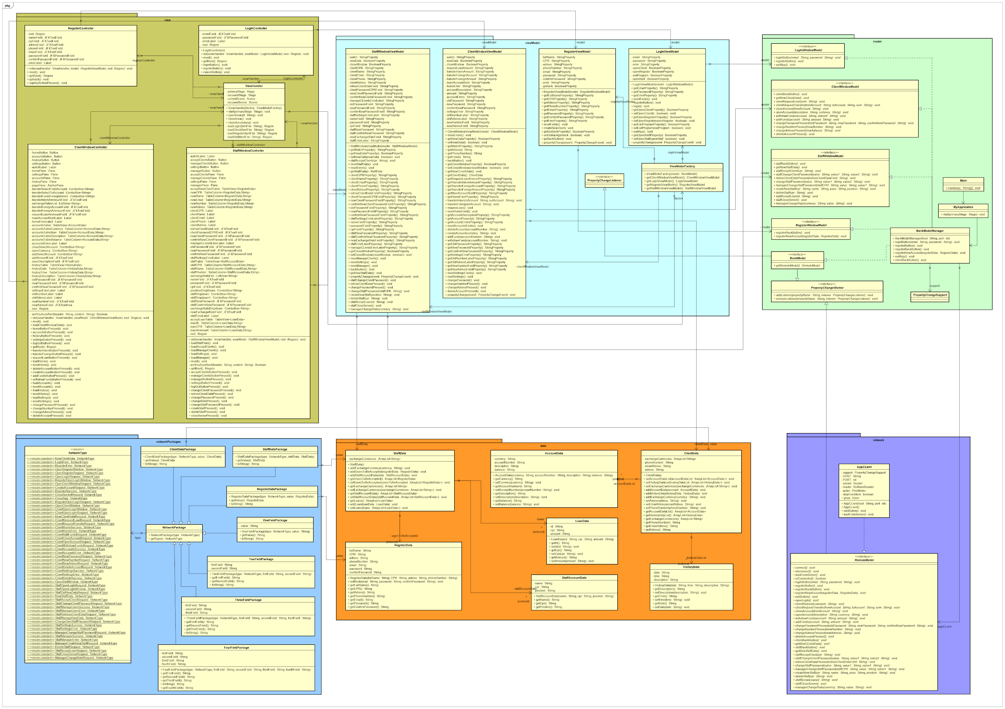

*Figure 10 - Client side class diagram*

Above is the resulting class diagram for the client-side of the software and all the relationships between the classes. As mentioned above, it follows the MVVM design pattern. For a more detailed image, access the Diagrams appendix.

**4.1.2**  **Server Side**

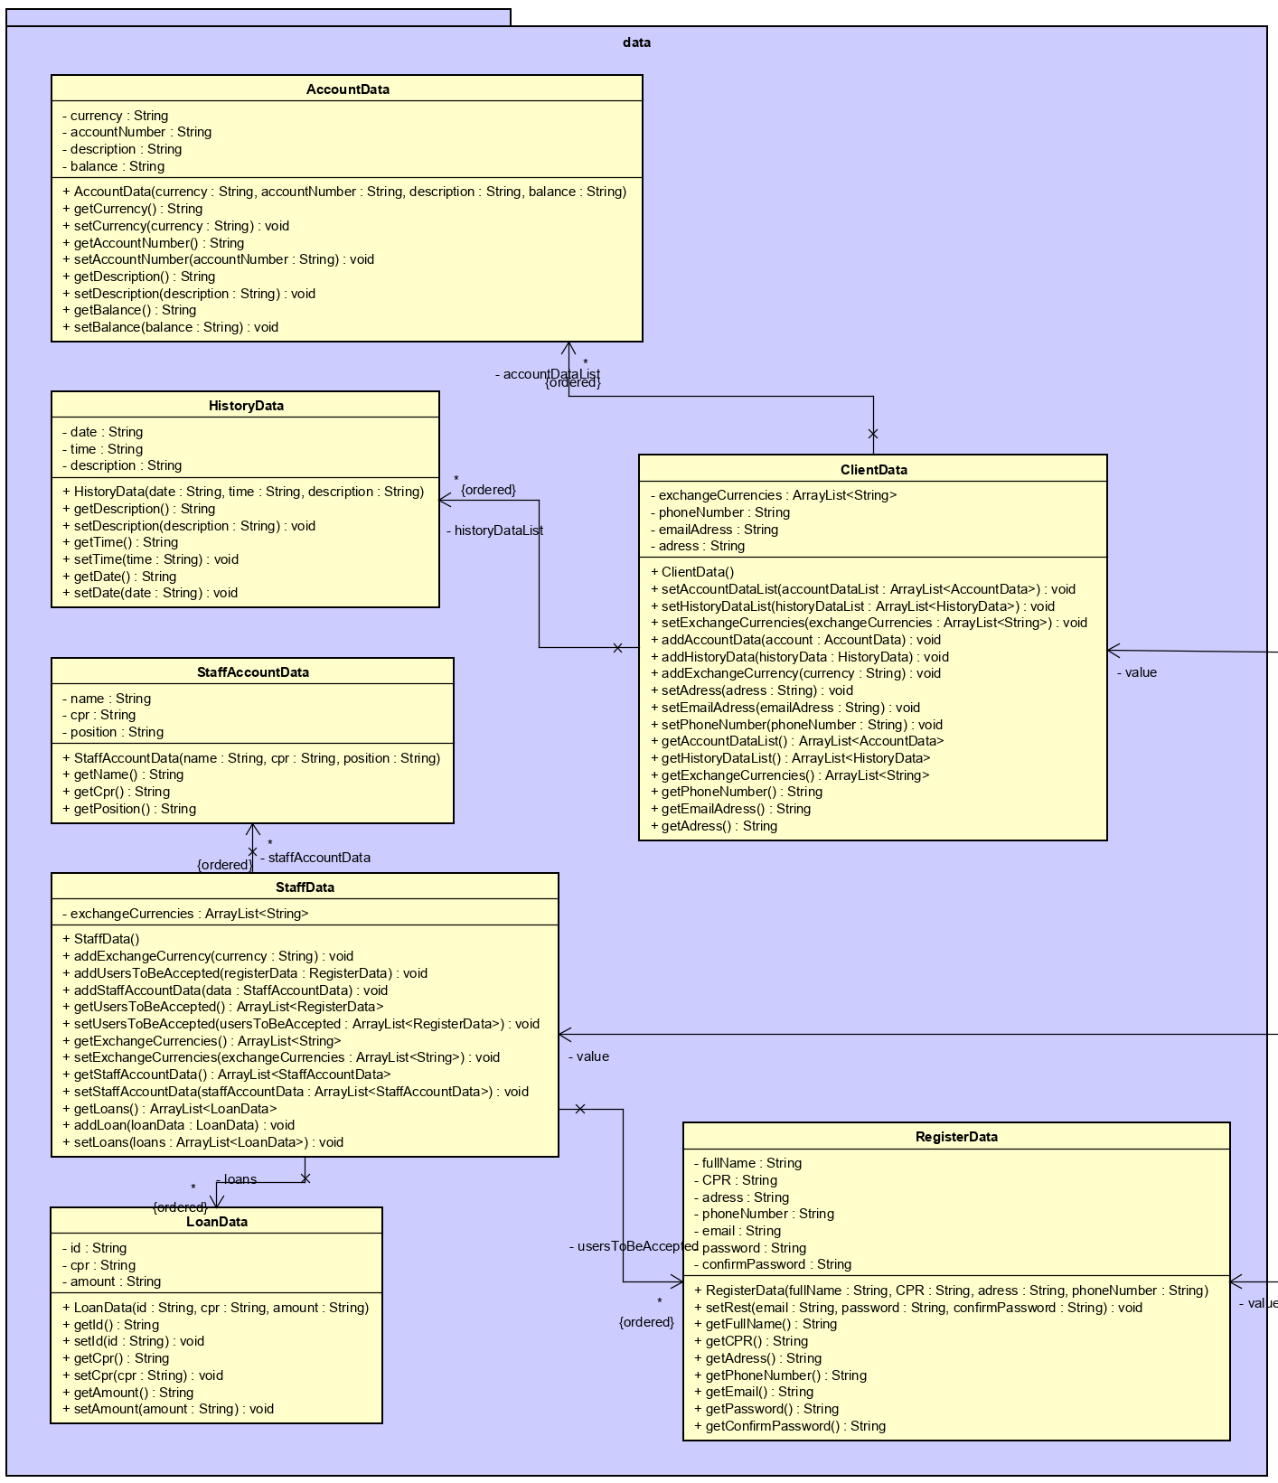

*Figure 11 - Server side data package*

The data package, similarly to the one from the client-side diagram, is responsible for holding objects used in client-server communication, and contains their attributes, constructors, getters and setters.

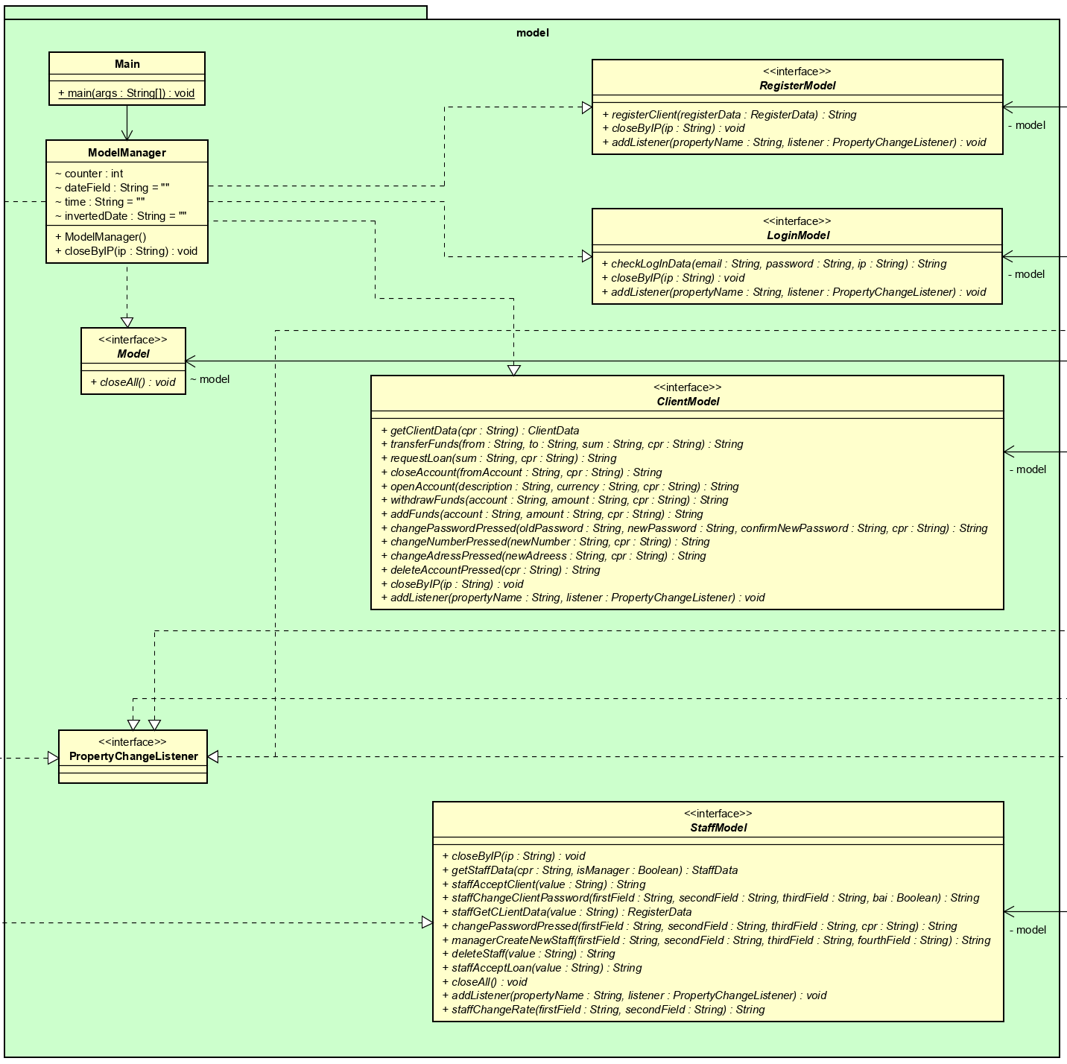

*Figure 12 - Server side model package*

The model package holds the main class, used to start the server, and the ModelManager that inherits from all the interfaces in the package - Model, LoginModel, RegisterModel, ClientModel, StaffModel. The ModelManager also executes all the requests from the client to the database.

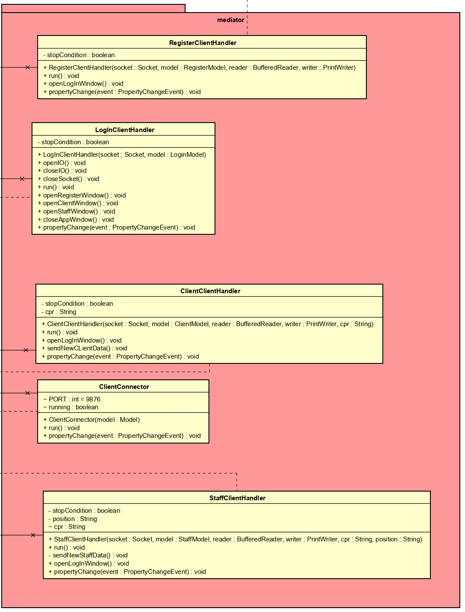

*Figure 13 - Server side mediator package*

The ClientConnector connects the clients to the server.

The RegisterClientHandler, LoginClientHandler, ClientClientHandler, and StaffClientHandler receive the client requests and send them to the ModelManager.

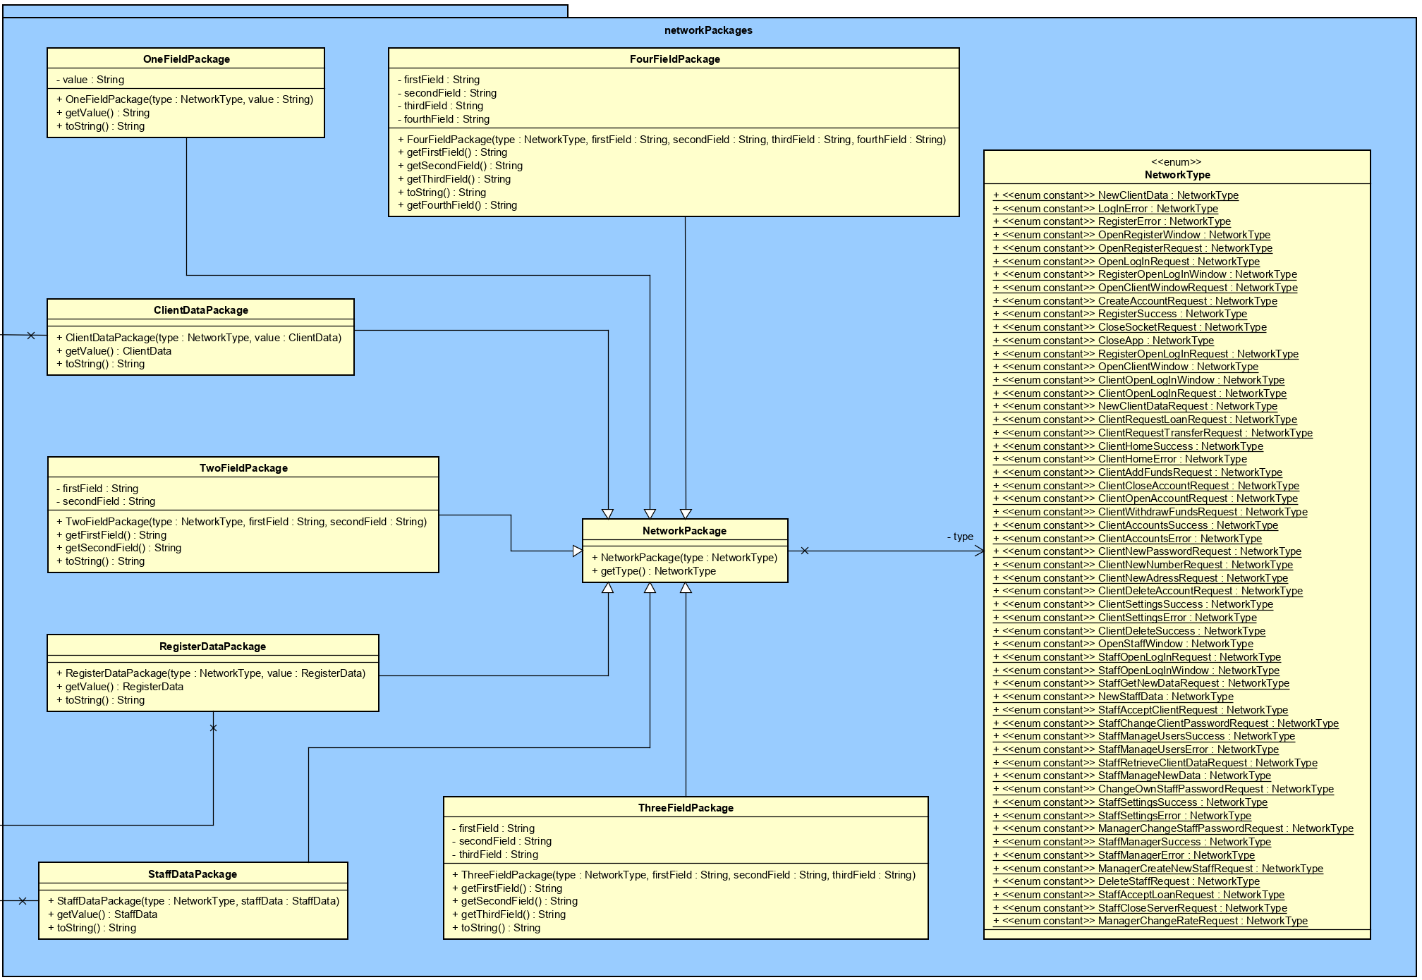

*Figure 14 - Server side networkPackages package*

Similarly to the networkPackages package from the client-side diagram, it contains classes that are used as wrappers for data to be sent to the server. The NetworkType holds all the types of network requests.

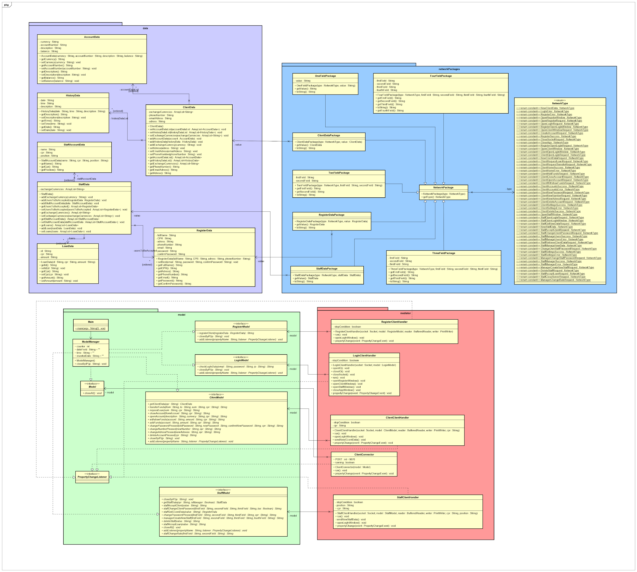

*Figure 15 - Server side class diagram*

Above is the resulting class diagram for the server-side of the software and all the relationships between the classes. For a more detailed image, access the Diagrams appendix.

* 1. **Sequence diagram**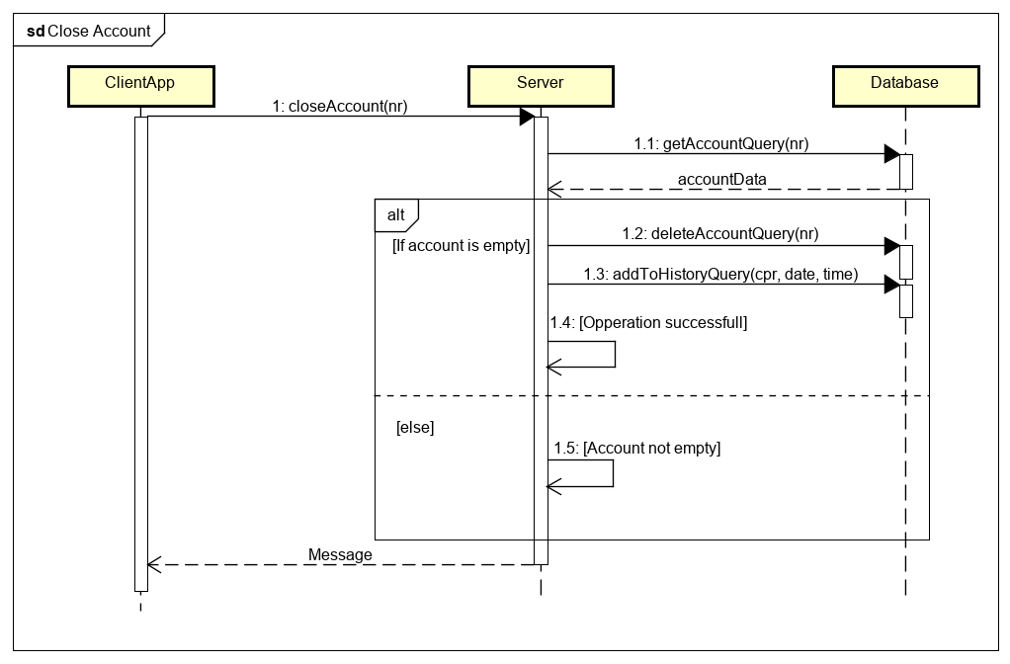
  2. **Database**

The following figure is the Entity/Relationship (E/R) model of the database that shows an overview of all the information (attributes) stored inside the five different entities: User, loan, account, history, exchange rate. The relationships between them are also represented in the figure, with all the cardinality, primary key and foreign key.

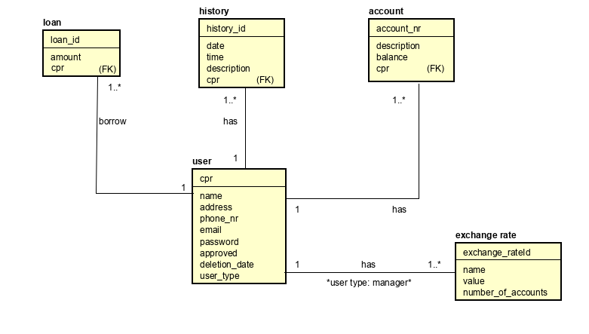

*Figure 16 - E/R Diagram*

The entity User relates to all other tables by one to many. The database should respect 1nf, 2nf and 3nf.

User (user has a variable type that contains customers, stuff and manager).

-address we keep it in user because we don’t use it in our system is a variable that helps the staff and manager with all the information about the customers.

The entity Exchange rate is connected to the user but only the manager has access to it.

The model was created in the PostgreSQL and implemented in our system.

Query :

CREATE DATABASE "BBB-DataBase";

CREATE SCHEMA bbb_dbs;

CREATE TABLE bbb_dbs.user (

cpr character(10) NOT NULL PRIMARY KEY,

name character varying(100) NOT NULL,

address character varying(100) NOT NULL,

phone_nr character varying(100) NOT NULL,

email character varying(100) NOT NULL,

password character varying(100) NOT NULL,

approved boolean NOT NULL,

deletion_date date,

user_type public.user_type NOT NULL

);

CREATE DOMAIN bbb_dbs.user_type AS character varying

CONSTRAINT user_type_check CHECK (((VALUE)::text = ANY ((ARRAY['client'::character varying, 'staff'::character varying, 'manager'::character varying])::text[])));

CREATE TABLE bbb_dbs.account (

account_nr character varying(100) NOT NULL PRIMARY KEY,

description character varying(500),

balance real,

cpr character(10) NOT NULL,

FOREIGN KEY(cpr) REFERENCES bbb_dbs.user(cpr)

);

CREATE TABLE bbb_dbs.exchange_rate (

name character(3) NOT NULL PRIMARY KEY,

value double precision,

number_of_accounts integer

);

CREATE TABLE bbb_dbs.history (

history_id integer NOT NULL PRIMARY KEY,

date date NOT NULL,

"time" time without time zone NOT NULL,

description character varying(500) NOT NULL,

cpr character(10) NOT NULL,

FOREIGN KEY(cpr) REFERENCES bbb_dbs.user(cpr)

);

CREATE TABLE bbb_dbs.loan (

loan_id integer NOT NULL PRIMARY KEY,

amount double precision NOT NULL,

cpr character(10) NOT NULL,

FOREIGN KEY(cpr) REFERENCES bbb_dbs.user(cpr)

);

* 1. **Graphical user interface**

*Figure 17 - Login window*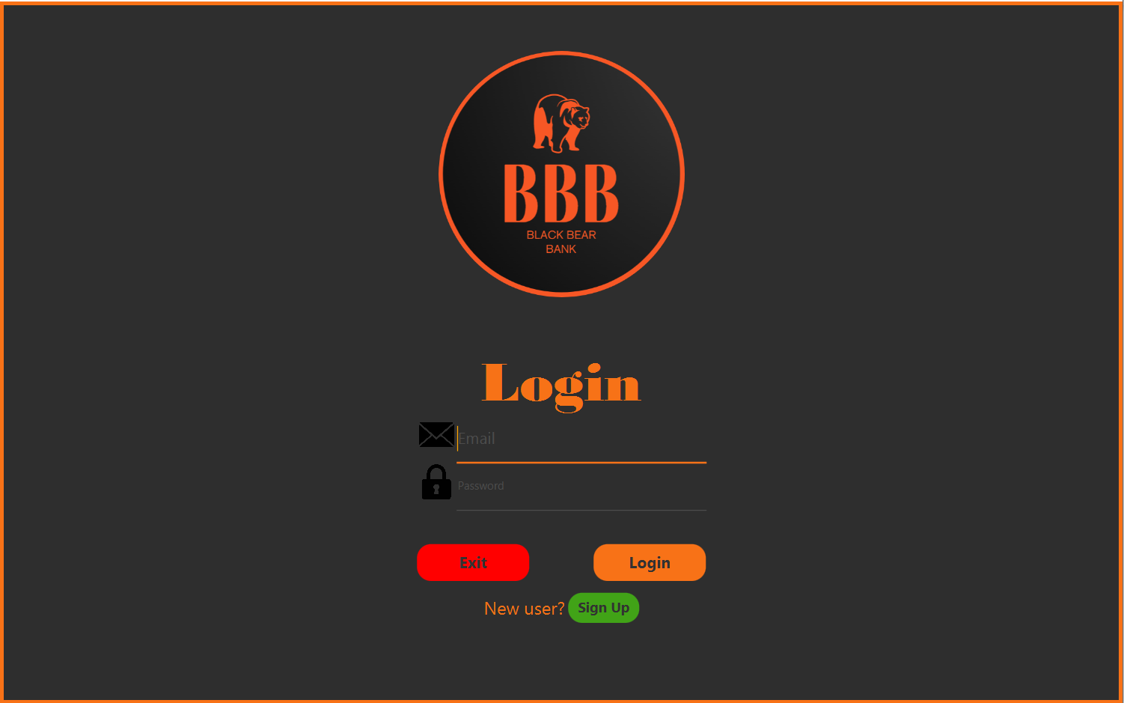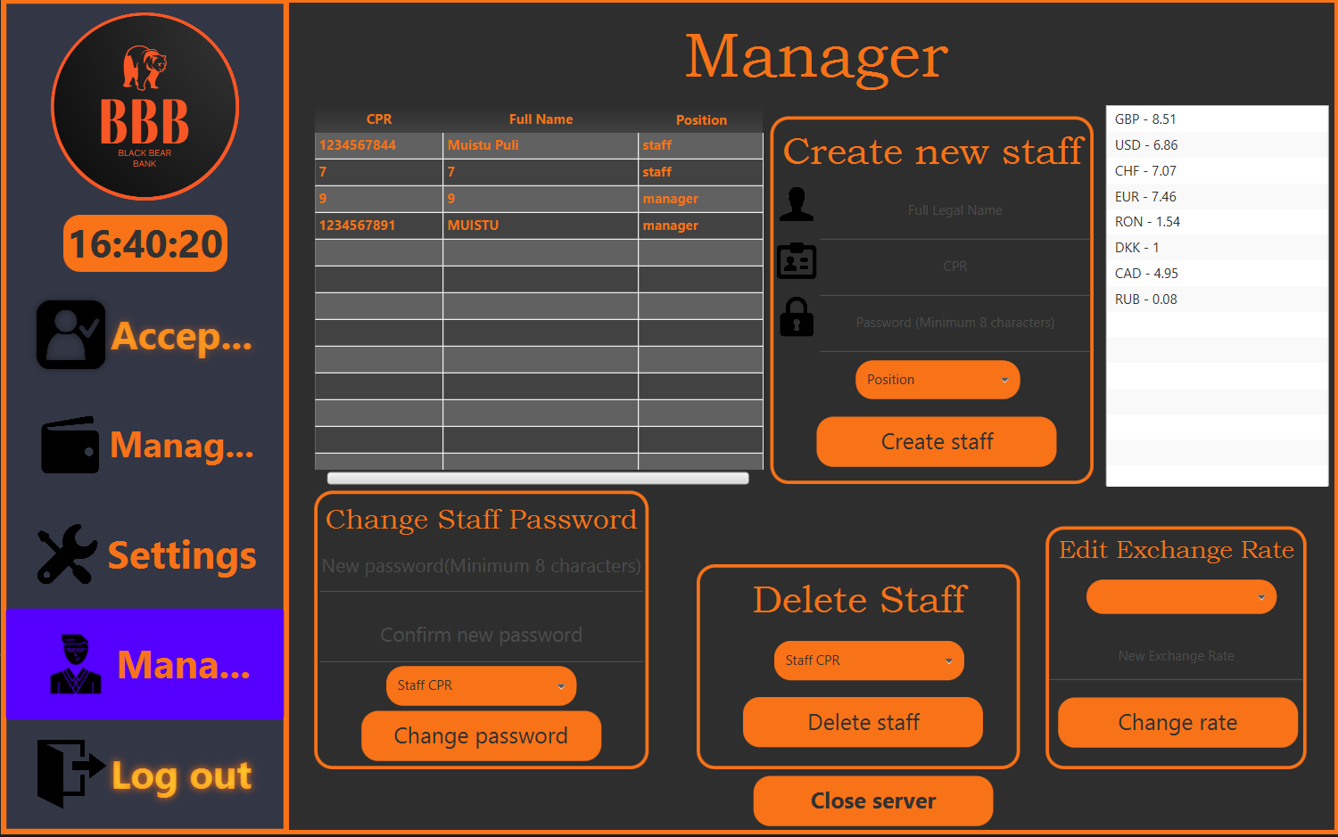

*Figure 18 - Manager window*

*Figure 19 - Accounts window*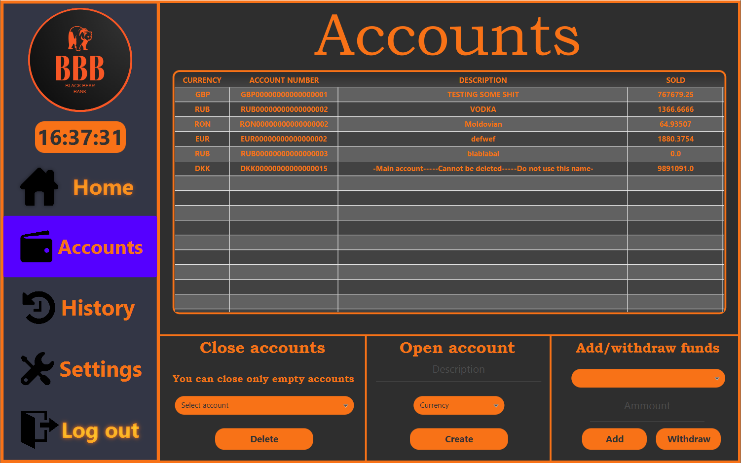

The graphical User Interface is designed to make it easy for the user to see his current account and manage his responsibilities according to the user type he has. The GUI is split into 4 windows (Staff, Log In, Register, Client). The Staff and Client window have 4 tabs each showing multiple actions. When a Staff Account logs in the Manager tab of the staff window is hidden so that a member of the staff cannot do Manager level of actions. The Client and Staff windows are opened by the server after checking the login data introduced and opening according to the user data inside the database. The technologies used to build the GUI are JavFX and Jfoenix(JavaFX Material design Library)

4.4 **Technologies**

The software has been developed in Java version 11.0.3, in the IntelliJ IDEA. The GUI has been made using the JavaFX platform and the JFoenix JavaFX material design library. The connection between the client and the server has been made using TCP sockets. The relational database management system used is PostgreSQL. The database has been developed through the pgAdmin 4 database management tool, and is being stored locally. All the diagrams have been made using Astah Professional.

# Implementation

* 1. **Checking the login data from the user by the server**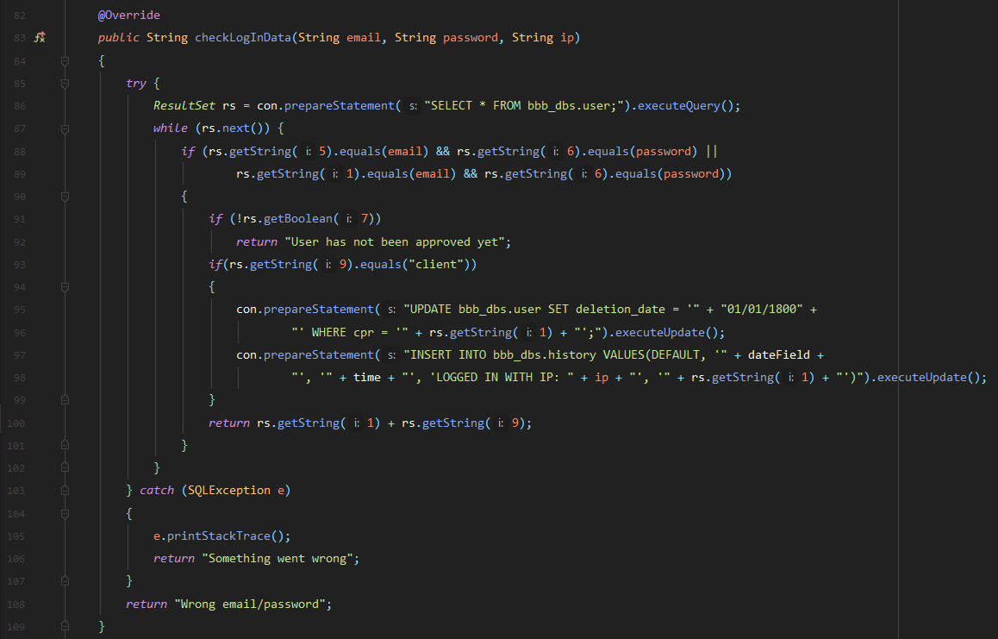

Shown above is the checkLogInData(String email, String password, String ip) from the ModelManager class used by the server inside the LogInClientHandler. This method returns different string data according to the data given on the method call and the data found inside the database.

con.prepareStatement("SELECT * FROM bbb_dbs.user;").executeQuery() (line 86) returns a list of users from the database

The returned user list is then searched for a match in the database to the data given when this method was called and if a match is found then the user is checked if he has been approved and if not returns an error message. After checking the data if the user type found is a client the delete date is reseted in case the user decided not to have his account deleted in the 6 months given creating a new entry in the users history stating the date, time and ip the user is logging in from.

The method returns a string containing the CPR and position of the user.

* 1. **Loading Client Window data**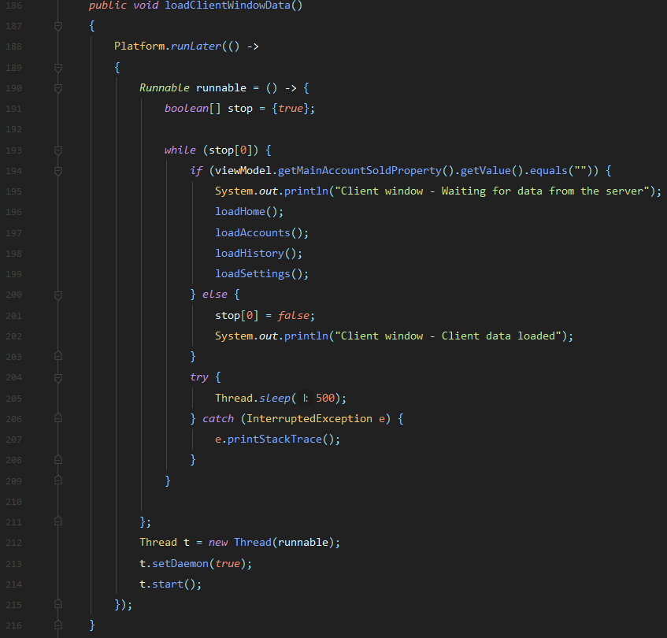

Shown above is the loadClientWindowData() method from the ClientWindowController class, which is called when the server sends the client application new data.

The method loads the tables, dropdown menus and labels of the GUI window ClientWindow.fxml.

When this method is called upon receiving new data from the server it creates a new thread, starts it and sets it to being daemon. While the main account sold label is empty the method will call the load data methods of this GUI window to try to load the data and then the thread sleeps for half a second and tries again until the data has been loaded and it stops the loops.

* + 1. **Load Accounts Method**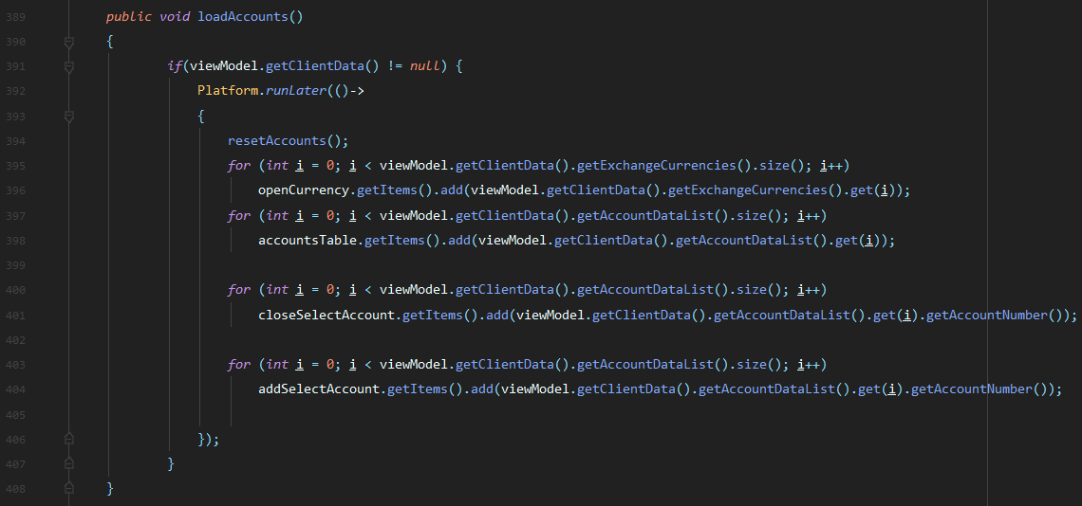

Shown above is the loadAccounts method from the ClientWindowController class, which is called by the loadClientWindowData method shown above. This method loads the dropdown menus and table of accounts inside the Accounts tab of the Client window GUI allowing the user to view the data of his account allowing him to take actions based on this data.

* + - 1. **Reset Accounts Method**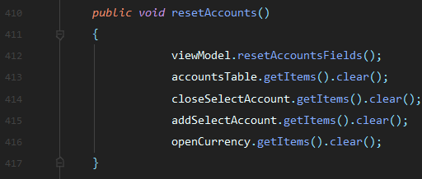

Shown above is the resetAccounts method from the ClientWindowController class, which is called by the loadAccounts method. This method is used to reset all of the dropdown menus and tables of accounts inside the Accounts tab in the Client Window making the GUI tab ready to be used again by the system to display the users account details.

* 1. **Server client request handling**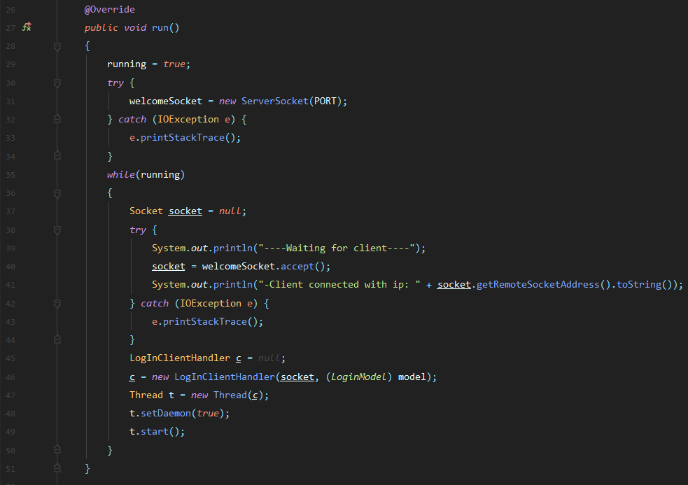

Show above is the run method inside the ClientConnector class used by the server. This method is used to allow the server to communicate with multiple users at the same time by creating a new individual thread and starting it for each user that connects to the main socket connection and then waiting for a new client.

The method shown above first opens a new TCP WelcomeSocket to receive connection requests to users then it enters an infinite loop to wait for a connection request by the user then creating a new LogInClientHandler for each user to be able to manage the users request individually.

* + 1. **LogInClientHandler**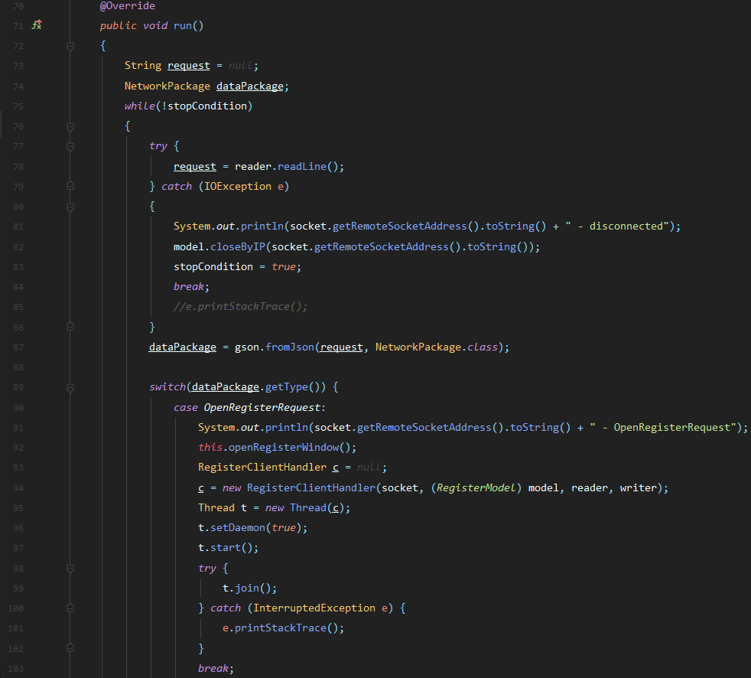

Show above is the first part of the run method of the LogInClientHandler class which is responsible for handling the user requests from the client LogIn GUI window.

This method first uses a while loop to continuously wait for a request from the user in the form of a NetworkPackage data package sent by JSON using sockets communication. Each iteration of the loop the method checks if the user is still connected and if he still is it treats the request according to its type and runs the appropriate action.

Show above is the code which runs when an OpenClientWindowRequest request is made by user GUI window LogIn. 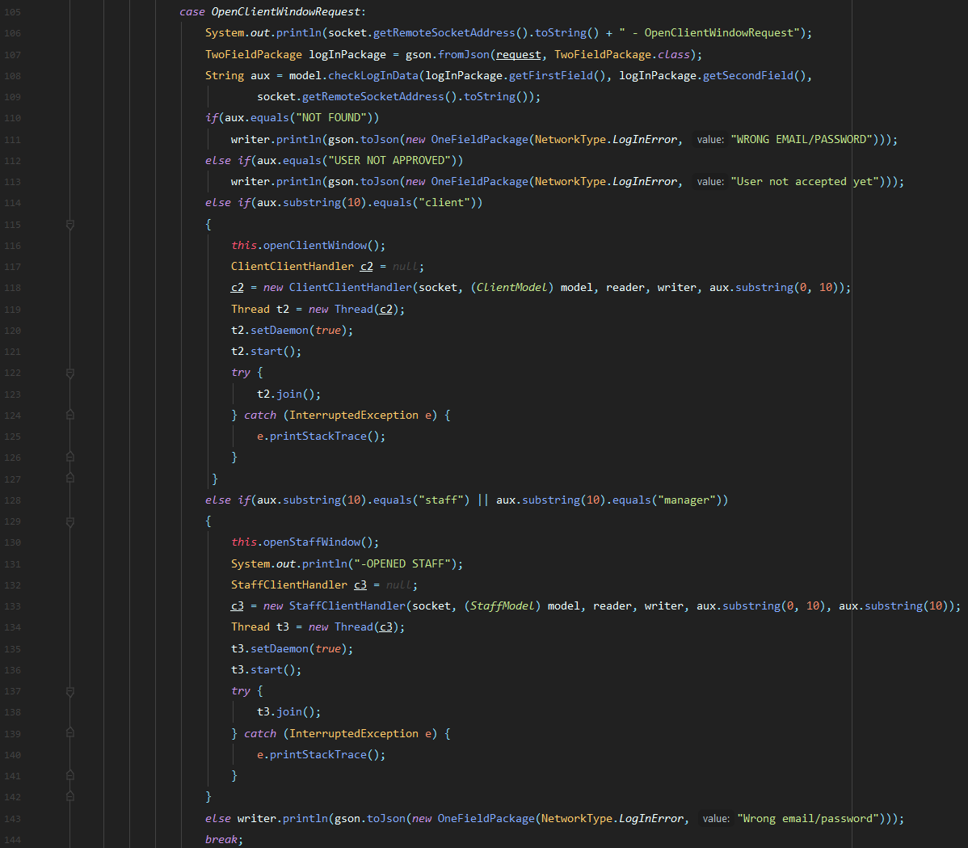

This request firstly converts the data package from a GSON(Google open source version of JSON) into a TwoFieldPackage containing the email/CPR and password of the user. Then this data is checked inside the ModelManager class and the result is stored in a temporary string variable. After that if the user was not found or not approved an appropriate message is sent back by the user with a OneFieldPackage data package of type LogInError and if the user is found and accepted it creates a new thread of the appropriate ClientHandler type and pauses the current thread until the sub-thread created is finished and sending the appropriate OpenWindow request.

* + 1. **Server request handling by the client**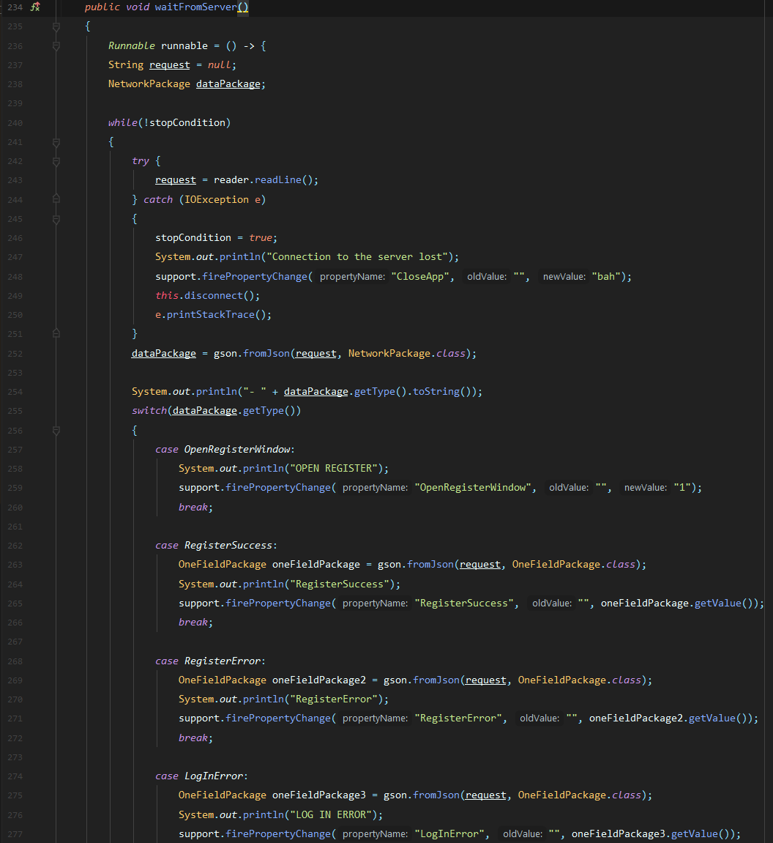

Shown above is the waitFromServer method used by the AppClient class of the client program. This method is used to handle all of the requests made by the server inside an infinite loop by firing PropertyChangeWorker property changes that start actions in different classes of the client program according to the particular request made by the server. This method automatically stops when the server disconnects and then the program is closed. If the server isn’t running the program won’t start.

The event fired by the AppClient class is received by the ModelManager class which fires other events according to the received events that are for the ViewModel’s that controls each GUI window.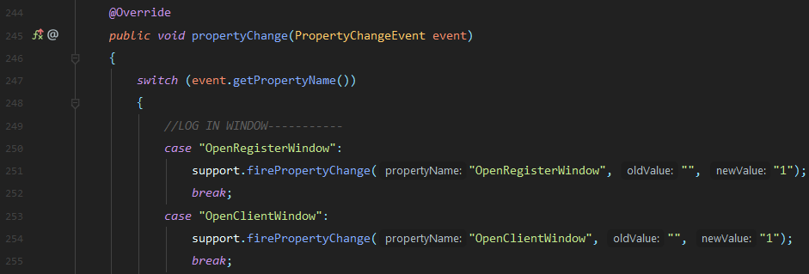

Inside the ViewModelFactory class, each View Model corresponding to a GUI window is instantiated and then added to the ModelManager’s list of listeners, connecting those classes using the Observer pattern.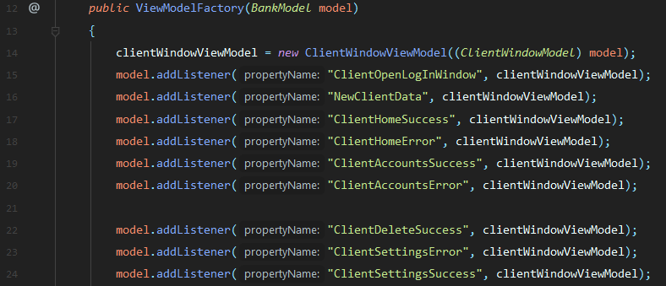

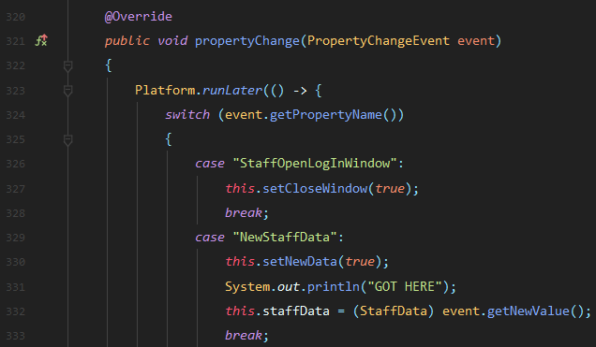

The events reach the appropriate View Model class and according to the event fired by the ModelManager class received from the AppClient class tha received requests from the banking server, the view model creates a new JavaFX thread using the Platform.runLater expression to edit the interface according to the request received and at the same time not freeze the interface while the update happens making the user think the program crashed.

# Test

The purpose of this section is to demonstrate that the code follows the use case descriptions. The testing method used was The Black Box, meaning that the testing was done from the perspective of the user. The results were gathered from multiple sessions of different people testing every functionality of the program

* 1. **Test cases**
     1. Register an account

|  |  |  |  |
| --- | --- | --- | --- |
| **Test ID** | **Description** | **Result** | **Comments** |
| TC-1.1 | Registering an account | Passed | The system will create an account only if the introduced data passes the conditions and before logging in the new account needs to be accepted by a staff member |

* + 1. Manage funds accounts

|  |  |  |  |
| --- | --- | --- | --- |
| **Test ID** | **Description** | **Result** | **Comments** |
| TC-2.1 | Depositing funds into own account | Passed |  |
| TC-2.2 | Withdrawing funds from own account | Passed | Cannot withdraw an amount greater than the one in the main account currently |
| TC-2.3 | Closing an account | Passed | Account must have 0 funds |
| TC-2.4 | Open account | Passed |  |

* + 1. Manage bank account personal data

|  |  |  |  |
| --- | --- | --- | --- |
| **Test ID** | **Description** | **Result** | **Comments** |
| TC-3.1 | Deleting account | Passed | The account will be deleted 6 months after the date of the action if the user doesn’t log on in this timespan |
| TC-3.2 | Changing password | Passed |  |
| TC-3.3 | Changing phone number | Passed | The system only allows danish phone numbers |
| TC-3.4 | Changing address | Passed |  |

* + 1. Transfer funds to own/foreign accounts in different currencies

|  |  |  |  |
| --- | --- | --- | --- |
| **Test ID** | **Description** | **Result** | **Comments** |
| TC-4.1 | Transfer funds to a foreign account | Passed | Cannot transfer an amount higher than the one in the source account or over 2 billion |
| TC-4.2 | Transfer funds to own account | Passed | Cannot transfer an amount higher than the one in the source account over 2 billion |

* + 1. Take loans in danish kroner

|  |  |  |  |
| --- | --- | --- | --- |
| **Test ID** | **Description** | **Result** | **Comments** |
| TC-5.1 | Take loan in DKK | Passed | Funds will be put into the main DKK account once the loan is accepted by a staff member and loan cannot be bigger than 2 billion DKK |

* + 1. Approve new customer

|  |  |  |  |
| --- | --- | --- | --- |
| **Test ID** | **Description** | **Result** | **Comments** |
| TC-6.1 | Approve new customer | Passed | After being approved by a staff member the client can connect to his account |

* + 1. Manage client data

|  |  |  |  |
| --- | --- | --- | --- |
| **Test ID** | **Description** | **Result** | **Comments** |
| TC-7.1 | Accepting client loan | Passed | After this step, the requested amount is transferred into the client's main account |
| TC-7.2 | Changing client password | Passed | Client CPR must be valid and new password must pass conditions |
| TC-7.3 | Retrieving client data | Passed | Client CPR must be valid |

* + 1. Shut down banking server

|  |  |  |  |
| --- | --- | --- | --- |
| **Test ID** | **Description** | **Result** | **Comments** |
| TC-6.1 | Manager shutting down the server | Passed | When the server shuts down all the client applications stop as well |

* + 1. Manage staff accounts

|  |  |  |  |
| --- | --- | --- | --- |
| **Test ID** | **Description** | **Result** | **Comments** |
| TC-9.1 | Create new staff member | Passed |  |
| TC-9.2 | Delete staff member | Passed |  |
| TC-9.3 | Change staff member password | Passed |  |

* + 1. Manage exchange rates

|  |  |  |  |
| --- | --- | --- | --- |
| **Test ID** | **Description** | **Result** | **Comments** |
| TC-10.1 | Edit exchange rate | Passed | DKK cannot be changed |

# Results and Discussion

After analyzing the supposed functionality that had to be implemented into the software, as to achieve the desired product, a list of 18 requirements was created. All of them have been successfully implemented.

The resulting software is working as intended, with all sections being functional. All the tests performed and documented in the previous section have all successfully passed.

Before the software development process, we had decided to use GitHub as a means to collaborate on its production. However several merge issues had been encountered and it has been decided to instead work individually and merge the progress during the team’s meet-ups. Although not as efficient as desired, this approach was satisfactory.

In the end, although the progress and the efficiency of the team was hindered because of the Covid-19 pandemic situation, which did not allow for as frequent meet-ups as desired, the final results of the project have been satisfactory.

# Conclusions

# Project future

The program is constantly improving, the current design of the project is made in such a way that it can be updated without conflict.

Here we have some proposals that would be implemented in our system:

The system would be able to cancel every payment that the client did not approve. The payment can be refused only by the staff members.

A mobile java application would be online soon for easy accessibility from a mobile device and an easier way to use our application from a mobile device.

Our system would use sockets TCP traffic encryption via asymmetric key encryption using the RSA encryption algorithm and SHA256 hashing for preventing man in the middle attacks that steal data transmitted between a client and a server.

Our client would have the possibility to order types of cards with different privileges and multiple client ranks (Basic, Premium, Platinum) that can be acquired for an amount of money or by the number of years of active usage. Also, they can have better exchange rates for a premium or if they have been customers of the BBB for a long time.

We would also add an exchange rate stock trading, cryptocurrency trading and Life insurance using 3rd party solutions would all be integrated into the software and ready to use by our customers.

Also, our system would have a website for our worker and customer so they can easily manage all the information about the bank without the software form.

Would have an exchange rate from where the currency is always updated so we don’t need to change it every time in our database.

Finally, we would add a login fail message when a customer, staff or manager wants to log on to SQL server and the user-id and password are incorrect.

# Sources of information

1. Aleksandre B, 2019. *Neobanks have arrived - is the market trembling?* [online] Bitnewstoday. Available at: <https://bitnewstoday.com/news/neobanks-have-arrived-is-the-market-trembling/> [Accessed 29 Feb. 2020].
2. [Cherowbrier](https://www.statista.com/aboutus/our-research-commitment), 2019. Online banking penetration in Great Britain from 2007 to 2019. [online] <https://www.statista.com/statistics/286273/internet-banking-penetration-in-great-britain/>[Accessed 29 Feb. 2020]

# Appendices

The purpose of your appendices is to provide extra information to the expert reader. List the appendices in order of mention.

Examples of appendices

* Project Description
* User Guide
* Source code – source documentation
* Diagrams
* Data sheets
* Etc.

**Appendix A Project Description**

Insert the original Project Description here